Capítulo XXX

The Quality of Urban Public Transport as a Catalyst for Social Transformation

LA CALIDAD DEL TRANSPORTE PÚBLICO URBANO COMO CATALIZADOR DE LA TRANSFORMACIÓN SOCIAL

Darwin Gabriel Manzano Cuenca

Instituto Superior Tecnológico Bolivariano de Tecnología
https://orcid.org/0000-0001-9770-1441

Maryuri García González

Universidad de la Habana
https://orcid.org/0000-0002-2734-6541

1. Introduction
Urban mobility shapes access to employment, education, healthcare, public services, and social participation. Its importance grows with urbanisation: the global urban population is projected to increase from 55% in 2018 to 68% by 2050 (UN DESA, 2019). However, only six in ten urban residents had convenient public transport access in 2023, with significant international disparities (United Nations, 2024).
Public transport functions as social infrastructure because its coverage, frequency, affordability, and accessibility connect populations with urban opportunities. Accessibility involves completing journeys under reasonable conditions of time, cost, safety, and autonomy (Saif et al., 2019). Its absence particularly affects low-income groups, persons with disabilities, older adults, and peripheral residents. Transport quality combines technical performance and user experience. Punctuality, regularity, safety, information, comfort, cleanliness, accessibility, and responsiveness influence satisfaction and continued use (Mugion et al., 2018; de Oña, 2021). Consequently, operational indicators must be integrated with perceptions, especially where centre–periphery inequalities persist (Tarko et al., 2026).
Quality transport may catalyse social transformation by reducing by reducing territorial, economic, physical, and informational barriers while supporting sustainable mobility (Mugion et al., 2018). In Guayaquil, Metrovía, conventional buses, and complementary modes still face limitations in coverage, integration, accessibility, safety, and perceived quality (Cabrera-Amaiquema, 2024; Manzano-Cuenca, 2025).
The central problem is not only the availability of vehicles or infrastructure, but the absence of an integrated management framework linking citizens’ expectations with technical, social, economic, and environmental indicators. This study therefore analyses urban public transport quality as a catalyst for social transformation, focusing on access to opportunities, inclusion, territorial equity, citizen well-being, and sustainable urban development. It assumes that improving quality requires a people-centred mobility model capable of reducing inequality and contributing to a more accessible, integrated, and socially just city.

1.1. Urban Public Transport Quality as a Multidimensional Construct
Urban mobility determines access to employment, education, healthcare, services, culture, and civic participation. With the urban population projected to rise from 55% to 68% by 2050, cities require inclusive and sustainable systems (UN DESA, 2019).
Public transport distributes urban opportunities, but routes alone do not ensure accessibility, which also depends on time, cost, frequency, safety, physical conditions, and autonomy (Saif et al., 2019). Deficiencies disproportionately affect vulnerable and peripheral populations.
Transport quality is multidimensional, SERVQUAL evaluates reliability, responsiveness, assurance, empathy, and tangible elements (Parasuraman et al., 1988). Transport applications also include punctuality, comfort, cleanliness, accessibility, information, safety, and operational performance (Eboli & Mazzulla, 2007). These factors influence satisfaction, continued use, and public trust (Mugion et al., 2018; de Oña, 2021), linking mobility quality to territorial equity and urban rights.

1.2. Public Transport as a Catalyst for Social Transformation in the Guayaquil Context
The relationship between public transport and social transformation lies in mobility systems’ capacity to redistribute urban accessibility. Reliable, affordable, safe, and universally accessible services expand opportunities and reduce territorial disadvantages. Conversely, deficient transport restricts access to employment, education, healthcare, and social interaction, reinforcing inequality and exclusion. Transport quality therefore shapes both mobility and participation in the city’s economic, institutional, and social life.
However, transport’s transformative potential is not an automatic consequence of infrastructure investment.. It depends on planning and management decisions that reduce physical, economic, informational, and territorial barriers. Public transport becomes a catalyst when it expands access to rights, services, and urban resources; narrows socio-spatial disparities; and enables underserved populations to participate more fully in urban life.
This perspective aligns with Sustainable Development Goal 11, particularly Target 11.2, which promotes safe, affordable, accessible, and sustainable transport for all, especially vulnerable groups, women, children, persons with disabilities, and older persons (United Nations, 2015). Efficient collective transport can also reduce private-vehicle dependence, congestion, energy consumption, and transport-related emissions (Banister, 2008; Mugion et al., 2018).
In Guayaquil, the transport system combines the Metrovía bus rapid transit network with conventional buses and complementary modes. Despite improvements along strategic corridors, challenges persist in territorial coverage, intermodal integration, accessibility, regularity, overcrowding, maintenance, information, and perceived safety. These limitations disproportionately affect peripheral residents, women, older adults, and persons with disabilities. Consequently, this study analyses transport quality through technical performance, user experience, and the social, economic, environmental, and institutional dimensions of mobility. Improvement requires a people-centred management model that expands opportunities, reduces territorial inequalities, strengthens public trust, and converts mobility into effective accessibility and social transformation.

2. objectives
For this study, the objectives should be aligned specifically with the relationship expressed in the title—public transport quality and social transformation—rather than reproducing the broader scope of the doctoral thesis. Nevertheless, they retain its multidimensional approach, its focus on Guayaquil, and the integration of technical indicators with users’ perceptions.

2.1. general objetive
To analyse how the quality of urban public transport can act as a catalyst for social transformation in Guayaquil by examining the relationship between technical and operational performance, users’ perceptions, accessibility, social inclusion, territorial equity, citizen well-being, and sustainable urban development.

2.2. Specific Objetives
- To systematise and operationalise the theoretical and methodological foundations and principal dimensions of urban public transport quality, including reliability, safety, accessibility, affordability, comfort, information, tangible conditions, and institutional responsiveness.
- To diagnose the quality of urban public transport in Guayaquil, with emphasis on the Metrovía system and conventional buses, by integrating technical, operational, social, economic, environmental, and user-perception indicators.
- To analyse how public transport quality influences accessibility, territorial equity, social inclusion, citizen well-being, and access to urban opportunities, and to formulate evidence-based guidelines for a people-centred and sustainable quality-management framework.

3. Metodology
This study adopts a convergent mixed-methods and non-experimental design to examine public transport quality in relation to accessibility, inclusion, territorial equity, well-being, and sustainable urban development. Quantitative and qualitative evidence will be collected concurrently, analysed separately, and integrated through triangulation. Quantitative analysis will assess frequency, punctuality, occupancy, infrastructure, accessibility, and operational performance; qualitative analysis will examine perceptions, satisfaction, trust, safety, and travel experiences (Manzano et al., 2026). Descriptive, correlational, and explanatory analyses will identify conditions, relationships, and pathways linking service quality to social outcomes. It will develop evidence-based management guidelines for Guayaquil, interpreting catalyst as facilitation rather than direct causality.

3.1. Study Area, Population, and Sampling
The study examines Guayaquil’s Metrovía system and conventional buses across central, intermediate, and peripheral areas. Participants include users and institutional actors involved in transport planning, operation, regulation, and evaluation. Users are selected through stratified sampling by service, route, zone, travel period, and usage frequency; experts and officials are purposively selected according to experience.
Transport quality is assessed through perceptual, operational, territorial, economic, environmental, and institutional dimensions. An adapted RATER/SERVQUAL scale is complemented by infrastructure audits, observation, passenger counts, documents, interviews, focus groups, and operational indicators to compare planned conditions, institutional performance, and actual user experiences.

3.2. Variables, Dimensions, and Data-Collection Instruments
The research includes documentary review, expert validation, pilot testing, surveys, accessibility audits, passenger counts, operational measurements, interviews, and focus groups. Data collected across selected routes, stations, and periods assess reliability, safety, accessibility, comfort, information, responsiveness, affordability, and user experience, integrating technical and perceptual evidence through transport-oriented SERVQUAL (Eboli & Mazzulla, 2007).
Quantitative data are analysed using descriptive and inferential statistics, reliability and validity procedures, and normalised composite indicators (Parasuraman et al., 1988). Qualitative findings are thematically analysed and triangulated with operational evidence. Participation is voluntary, confidential, and based on informed consent.

TABLE 1. Preliminary validation of the research instruments
 | Instrument design |  | Content validity | Reliability / consistency | Final assessment
Instrument | Items | Type | Aiken’s V | α / Kappa | Status
User survey on perceived quality | 32 | Likert scale | 0.94 | 0.91 | Accepted
Infrastructure and accessibility checklist | 24 | Checklist | 0.92 | 0.84 | Accepted
Direct observation sheet | 18 | Observation record | 0.90 | 0.81 | Accepted
Passenger count form | 10 | Record sheet | 0.95 | 0.87 | Accepted
Operational indicator matrix | 14 | Technical matrix | 0.96 | 0.89 | Accepted
Semi-structured interview guide | 12 | Interview protocol | 0.93 | 0.86* | Accepted with adjustments
Focus group guide | 10 | Discussion guide | 0.91 | 0.83* | Accepted with adjustments
Note. Consistency coefficient estimated from
pilot agreement criteria.
Source: Prepared by the author.
Table 1 summarises the preliminary validation of the research instruments. The 32-item user survey showed high content validity and internal consistency (Aiken’s V = 0.94; Cronbach’s α = 0.91), while the remaining quantitative instruments also obtained acceptable validity and reliability values. The interview and focus group guides were considered suitable after minor wording and sequencing adjustments, confirming the overall adequacy of the instrument set for analysing public transport quality.

4. RESULTS

4.1. Sample Distribution and Public Transport Use Profile
The simulated diagnostic sample comprised 400 urban public transport users, equally distributed across four strategic application points linked to the Metrovía trunk system. Each location contributed 100 respondents, representing 25% of the total sample. This proportional allocation was designed to avoid concentrating the analysis in a single corridor and to include central, institutional, commercial, and peripheral urban contexts, thereby reflecting different mobility conditions and user experiences across Guayaquil. The results presented correspond to the simulated diagnostic scenario incorporated into the doctoral research and should therefore be interpreted as preliminary analytical evidence rather than definitive empirical findings. Inferential coefficients and PLS-SEM models were not estimated because verified individual-level survey data were not yet available.
Table 2. Distribution of the Sample by Application Point
Application point | Metrovía trunk | Urban context | Respondents | Percentage
Biblioteca Municipal | Trunk 1 | Central administrative and commercial area | 100 | 25.0%
Universidad de Guayaquil | Trunk 2 | Educational and high-demand area | 100 | 25.0%
Caja del Seguro | Trunk 3 | Institutional and employment area | 100 | 25.0%
Batallón del Suburbio | Trunk 4 | Peripheral residential area | 100 | 25.0%
Total | — | — | 400 | 100.0%
Note. Simulated distribution based on the diagnostic design.
Source: Prepared by the author from the research database.
The sample was predominantly composed of regular users. Daily passengers represented 47% of respondents, while those using public transport between three and five times per week accounted for 28%. Consequently, 75% of the sample consisted of frequent users with sufficient experience to assess recurrent service conditions. Similarly, 75% of the surveys were assigned to morning or evening peak periods, when overcrowding, waiting-time variability, and operational disruptions become more visible.
Table 3. Distribution by Frequency of Use and Time Period
Classification | Category | Respondents | Percentage
Frequency of use | Daily | 188 | 47.0%
 | 3–5 times per week | 112 | 28.0%
 | 1–2 times per week | 64 | 16.0%
 | Occasional | 36 | 9.0%
Time period | Morning peak period | 150 | 37.5%
 | Off-peak period | 100 | 25.0%
 | Evening peak period | 150 | 37.5%
Note. Percentages for frequency of use and time
period are calculated independently.
Source: Prepared by the author.

4.2. Perceived Quality of Urban Public Transport
Urban public transport quality received a low-to-moderate assessment, averaging 2.53 out of 5 across eight dimensions, below the minimally acceptable value of 3.00. No dimension achieved a satisfactory level. Responsiveness obtained the lowest score (2.31), reflecting deficiencies in communicating delays, addressing incidents and complaints, and providing timely information. Safety scored 2.34 because of theft risks, overcrowding, limited surveillance, and inadequate lighting. Tangibility reached 2.46, revealing concerns regarding the condition, cleanliness, maintenance, and comfort of vehicles and infrastructure.
Table 4. Descriptive Results by Perceived-Quality Dimension
Dimension | Mean | Standard deviation | Approximate 95% CI | Interpretation
Reliability | 2.71 | 0.91 | 2.62–2.80 | Low–moderate
Safety | 2.34 | 0.96 | 2.25–2.43 | Low
Tangibility | 2.46 | 0.88 | 2.37–2.55 | Low
Accessibility | 2.58 | 0.90 | 2.49–2.67 | Low–moderate
Empathy | 2.69 | 0.84 | 2.61–2.77 | Low–moderate
Responsiveness | 2.31 | 0.93 | 2.22–2.40 | Low
Perceived value | 2.62 | 0.87 | 2.53–2.71 | Low–moderate
Overall satisfaction | 2.55 | 0.89 | 2.46–2.64 | Low–moderate
Intention to use if the service improves | 3.81 | 0.78 | 3.73–3.89 | High
Note. Scale: 1 = very low and 5 = very high.
Confidence intervals were estimated from the
simulated aggregate data using n = 400
and should be recalculated with the final database.
Source: Prepared by the author.
GRAPHIC 1. Perceived public transport quality by dimension.
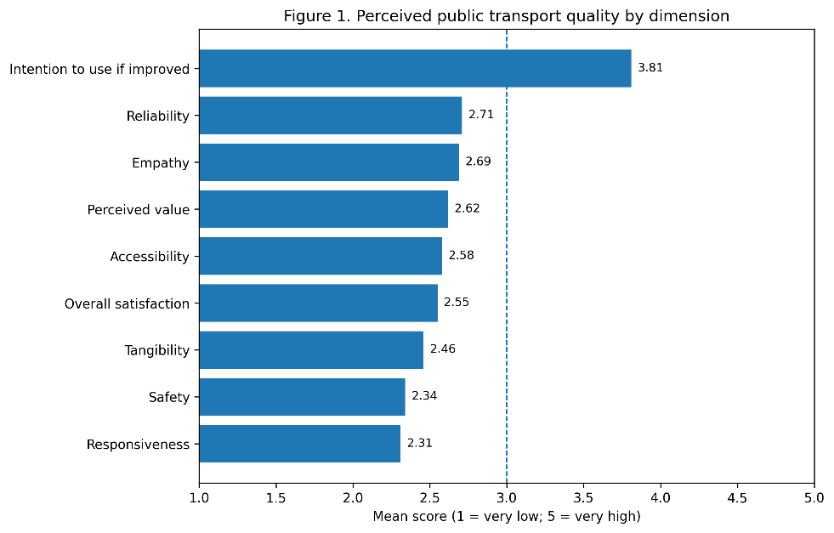
Source: Prepared by the author.
Reliability and empathy obtained the highest scores, at 2.71 and 2.69, although both remained below the satisfactory threshold. Reliability problems concerned frequency, regularity, waiting times, and expected travel conditions. Accessibility scored 2.58, revealing persistent barriers for older adults, persons with disabilities, passengers with reduced mobility, and users requiring transfers.
Overall satisfaction reached only 2.55, while willingness to continue using public transport if conditions improved rose to 3.81. This 1.26-point gap indicates dependence on the service, limited affordable alternatives, and latent demand for safer, more reliable transport. Continued use therefore reflects necessity rather than genuine satisfaction.
GRAPHIC 2. Gab between current satisfaction and conditional use intention.
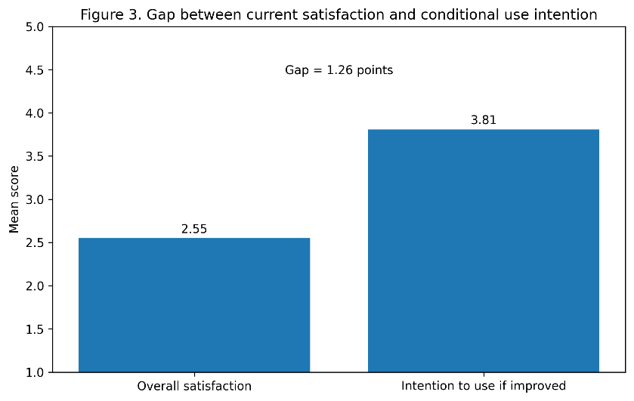
Source: Prepared by the author.

4.3. Territorial Differences in Perceived Quality
The results reveal differences among the four application points. Biblioteca Municipal registered the highest overall mean, with 2.64, followed by Universidad de Guayaquil with 2.59 and Caja del Seguro with 2.52. Batallón del Suburbio obtained the lowest assessment, with a mean of 2.38.
Table 5. Perceived Quality by Application Point
Application point | Mean perceived quality | Difference from highest score | Most critical dimension
Biblioteca Municipal | 2.64 | — | Responsiveness
Universidad de Guayaquil | 2.59 | −0.05 | Safety
Caja del Seguro | 2.52 | −0.12 | Tangibility
Batallón del Suburbio | 2.38 | −0.26 | Safety and accessibility
Note. The difference was calculated using
Biblioteca Municipal as the
highest-scoring reference point.
Source: Prepared by the author.

GRAPHIC 2. Overall perceived quality by application point
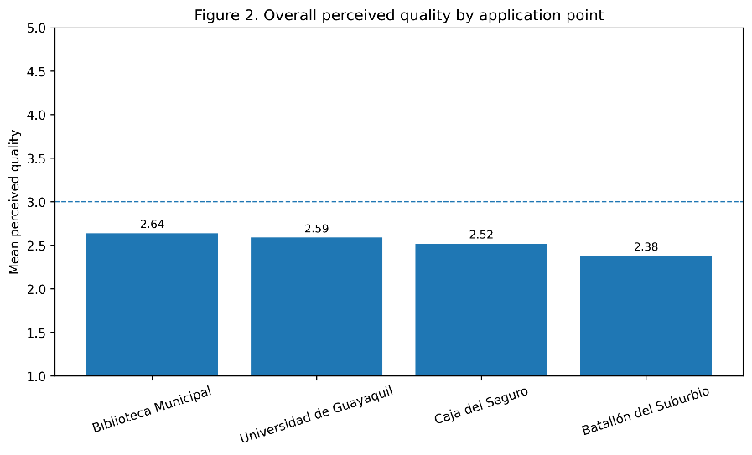
Source: Prepared by the author.
The 0.26-point gap between Biblioteca Municipal and Batallón del Suburbio reveals territorial differences in perceived quality. Batallón del Suburbio showed the greatest safety and accessibility problems, while Biblioteca Municipal performed comparatively better but remained unsatisfactory. Universidad de Guayaquil’s main weakness was safety, associated with overcrowding and peak-hour exposure. Caja del Seguro presented deficiencies in maintenance, cleanliness, infrastructure, and facilities, whereas Biblioteca Municipal lacked responsiveness and timely information.
These results show that transport problems vary territorially. Central areas generally offer greater connectivity, while peripheral users face longer access times, fewer alternatives, insecurity, and greater dependence. Consequently, assessments require disaggregated territorial indicators rather than citywide averages.

4.4. Prioritisation of Critical Service Dimensions
To establish an initial hierarchy of intervention, a quality-deficit score was calculated by subtracting the observed mean from the maximum value of the scale:
$$Quality deficit=5-observed mean$$
A higher deficit represents a greater distance from the optimal service condition.
Table 6. Priority Ranking of Service-Quality Dimensions
Priority | Dimension | Observed mean | Quality deficit | Strategic implication
1 | Responsiveness | 2.31 | 2.69 | Strengthen incident management, communication, complaints processing, and real-time information
2 | Safety | 2.34 | 2.66 | Improve surveillance, lighting, crowd management, and preventive security protocols
3 | Tangibility | 2.46 | 2.54 | Renew and maintain vehicles, stops, stations, signage, and passenger facilities
4 | Accessibility | 2.58 | 2.42 | Remove physical and informational barriers and improve universal access
5 | Empathy | 2.69 | 2.31 | Strengthen staff training and differentiated assistance
6 | Reliability | 2.71 | 2.29 | Improve regularity, headway control, punctuality, and waiting-time predictability
Note. The deficit is a derived descriptive indicator
and does not represent a validated
composite index.
Source: Prepared by the author.

The ranking indicates that the most urgent interventions should not be limited to increasing the number of vehicles. The most substantial deficits involve the relationship between the system and its users: the ability to protect passengers, communicate effectively, respond to disruptions, and maintain adequate physical conditions. Operational improvements are necessary, but they must be accompanied by institutional, informational, and territorial measures.

4.5. Relationship Between Transport Quality and Social Transformation
The results support the interpretation of public transport quality as a potential enabling condition for social transformation. However, the findings do not establish direct causality. They show that poor service quality creates barriers that may restrict access to opportunities, intensify territorial inequality, and weaken citizens’ confidence in public institutions.
Table 7. Relationship Between Main Findings and Social Implications
Main finding | Social implication | Management priority
Low safety assessment | Greater exposure of vulnerable users and restrictions on travel times and destinations | Safe stations, lighting, surveillance, and differentiated protection measures
Low responsiveness | Reduced institutional trust and greater uncertainty during disruptions | Real-time information, complaint traceability, and incident-response protocols
Low tangibility | Deterioration of comfort, dignity, and perceived service value | Preventive maintenance and infrastructure renewal
Accessibility barriers | Restricted autonomous mobility for persons with disabilities and older adults | Universal design, accessible vehicles, signage, and staff assistance
Lower quality in the peripheral sector | Reproduction of territorial disadvantages and unequal access to opportunities | Territorial redistribution of service coverage and infrastructure investment
High conditional intention to use | Presence of latent demand and dependence on affordable collective mobility | Improve service quality before promoting behavioural change or modal transition
Source: Prepared by the author.
The findings reveal a socially indispensable system whose continued use reflects limited affordable alternatives rather than consistent satisfaction. Improving transport quality could support social transformation by expanding access to employment, education, healthcare, and public services; strengthening safety, autonomy, trust, and participation; and reducing territorial disadvantages in peripheral areas. Public transport quality should therefore be understood not only as an operational variable, but also as an indicator of institutional capacity, territorial justice, and equitable access to urban opportunities. In Guayaquil, its greatest transformative potential lies in shifting from compulsory dependence to a reliable, safe, accessible, and socially dignified mobility system.

5. Discussion
The findings show that public transport quality in Guayaquil remains unsatisfactory, particularly regarding responsiveness, safety, and tangible conditions. Dissatisfaction reflects unreliable service, insecurity, inadequate infrastructure, limited information, and weak institutional response. This confirms SERVQUAL’s multidimensional approach, which compares user expectations with experienced service (Parasuraman et al., 1988). In transport, quality depends on punctuality, frequency, accessibility, safety, physical conditions, information, and staff behaviour (Eboli & Mazzulla, 2007). Responsiveness was the most critical dimension: insufficient real-time information, disruption management, and complaint resolution reduce users’ ability to anticipate journeys. Thus, the quality deficit is simultaneously technical, organisational, and communicational.
GRAPHIC 3. Dimensions of public transport quality
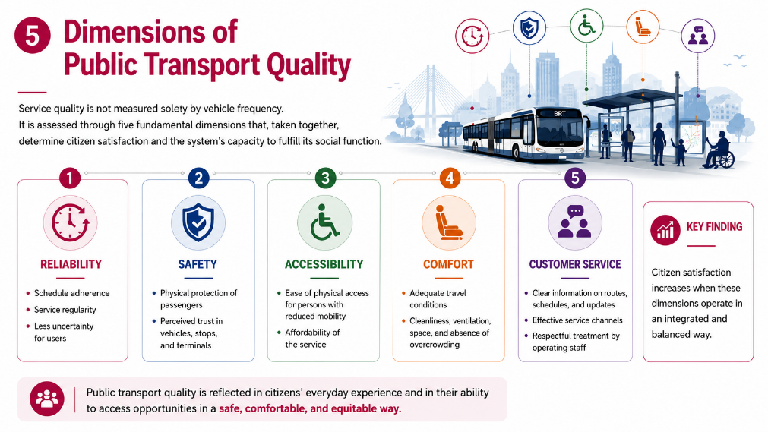
Note. Prepared by the author based
on the dimensions analysed in the study.
Safety emerged as the second most critical dimension, particularly for women, older adults, persons with disabilities, students, and peripheral residents. Its assessment should combine objective records with perceptions of lighting, surveillance, overcrowding, design, and staff presence. Accessibility also includes reaching stops, boarding, understanding information, affording journeys, transferring, and arriving promptly (Saif et al., 2019).
Batallón del Suburbio’s lower evaluation reveals accumulated territorial disadvantages concealed by citywide averages. The satisfaction–willingness gap suggests latent demand, while continued use may reflect economic dependence rather than satisfaction (de Oña, 2021; Mugion et al., 2018).
Transport quality can foster transformation through accessibility, inclusion, and territorial equity, consistent with SDG 11.2 (United Nations, 2015). A people-centred model requires participation, coordination, measurable standards, traceable data, and transparent monitoring. However, these simulated diagnostic results require validation through final surveys and operational databases before being considered definitive evidence.

6. Conclusions
Urban public transport quality is a multidimensional phenomenon that combines technical performance, user experience, accessibility, safety, affordability, infrastructure, information, and institutional responsiveness. In Guayaquil, the diagnostic scenario shows that perceived quality remains below a satisfactory level, particularly in responsiveness, safety, tangible conditions, and accessibility.
The findings reveal that service deficiencies are not exclusively operational. Weak communication, limited incident management, inadequate complaint mechanisms, insecurity, deteriorated infrastructure, and territorial disparities directly affect user confidence and everyday mobility. Peripheral areas appear to experience greater disadvantages, demonstrating the need for territorially disaggregated indicators and targeted interventions.
The gap between current satisfaction and conditional intention to use the service confirms that there is demand for safer, more reliable, accessible, and dignified public transport. Continued use should not be interpreted as satisfaction because it may reflect the absence of affordable alternatives.
Public transport quality can act as a catalyst for social transformation when it expands access to employment, education, healthcare, public services, and social participation; reduces territorial barriers; and strengthens the autonomy of vulnerable populations. However, these effects depend on coordination with land-use, housing, employment, security, environmental, and social policies.
The study therefore supports the adoption of an integrated, people-centred management model based on measurable standards, transparent data, citizen participation, institutional accountability, and continuous improvement. Improving public transport quality in Guayaquil should be understood not only as a technical objective, but as a strategic investment in social inclusion, territorial cohesion, sustainable development, and urban justice.

8. Referencias
Aiken, L. R. (1985). Three coefficients for analyzing the reliability and validity of ratings. Educational and Psychological Measurement, 45(1), 131–142. https://doi.org/10.1177/0013164485451012
Akao, Y. (1990). Quality function deployment: Integrating customer requirements into product design. Productivity Press.
Banister, D. (2008). The sustainable mobility paradigm. Transport Policy, 15(2), 73–80. https://doi.org/10.1016/j.tranpol.2007.10.005
Braun, V., & Clarke, V. (2022). Thematic analysis: A practical guide. SAGE.
Cabrera-Amaiquema, J. E. (2024). Design, Analysis and Detection of Urban Mobility Patterns in Guayaquil through Supervised Learning Algorithms. YUYAY: Estrategias, Metodologías & Didácticas Educativas, 3(2), 1-21. https://doi.org/10.59343/yuyay.v3i2.70
Creswell, J. W., & Plano Clark, V. L. (2018). Designing and conducting mixed methods research (3rd ed.). SAGE.
Cronbach, L. J. (1951). Coefficient alpha and the internal structure of tests. Psychometrika, 16(3), 297–334. https://doi.org/10.1007/BF02310555
de Oña, J. (2021). Understanding the mediator role of satisfaction in public transport: A cross-country analysis. Transport Policy, 100, 129–149. https://doi.org/10.1016/j.tranpol.2020.09.011
Eboli, L., & Mazzulla, G. (2007). Service quality attributes affecting customer satisfaction for bus transit. Journal of Public Transportation, 10(3), 21–34. https://doi.org/10.5038/2375-0901.10.3.2
Guglielmetti Mugion, R., Toni, M., Raharjo, H., Di Pietro, L., & Sebathu, S. P. (2018). Does the service quality of urban public transport enhance sustainable mobility? Journal of Cleaner Production, 174, 1566–1587. https://doi.org/10.1016/j.jclepro.2017.11.052
Hair, J. F., Jr., Hult, G. T. M., Ringle, C. M., & Sarstedt, M. (2022). A primer on partial least squares structural equation modeling (PLS-SEM) (3rd ed.). SAGE.
Linstone, H. A., & Turoff, M. (Eds.). (1975). The Delphi method: Techniques and applications. Addison-Wesley.
Manzano Cuenca, D. G. (2025). Calidad de servicio del transporte público urbano en Guayaquil [Unpublished doctoral dissertation manuscript]. Universidad de La Habana.
Manzano Cuenca, D. G., García González, M., & Sandoval Villamar, E. D. (2026). Modelo integrado de gestión de la calidad para el transporte público urbano: un enfoque metodológico basado en la percepción del usuario e indicadores operativos. Economía Y Desarrollo, 170(1), 210–237. Recuperado a partir de https://revistas.uh.cu/econdesarrollo/article/view/12763
Manzano-Cuenca, D. G. (2025). Urban mobility, social cohesion, equity and quality of life in Guayaquil: A systematic review. YUYAY: Estrategias, Metodologías & Didácticas Educativas, 5(1), 20–46. https://doi.org/10.59343/yuyay.v5i1.120
Parasuraman, A., Zeithaml, V. A., & Berry, L. L. (1988). SERVQUAL: A multiple-item scale for measuring consumer perceptions of service quality. Journal of Retailing, 64(1), 12–40.
Saaty, T. L. (1980). The analytic hierarchy process: Planning, priority setting, resource allocation. McGraw-Hill.
Saif, M. A., Zefreh, M. M., & Torok, A. (2019). Public transport accessibility: A literature review. Periodica Polytechnica Transportation Engineering, 47(1), 36–43. https://doi.org/10.3311/PPtr.12072
Tarko, A. C., Matichescu, M. L., Răducan, M.-R., & Dragan, A. (2026). Public transport accessibility level and public perceptions: A framework for urban mobility analysis. Urban Science, 10(2), Article 122. https://doi.org/10.3390/urbansci10020122
United Nations, Department of Economic and Social Affairs, Population Division. (2019). World urbanization prospects: The 2018 revision (ST/ESA/SER.A/420). United Nations. https://population.un.org/wup/Publications/Files/WUP2018-Report.pdf
United Nations. (2015). Transforming our world: The 2030 Agenda for Sustainable Development (A/RES/70/1). https://sdgs.un.org/2030agenda
United Nations. (2024). The Sustainable Development Goals Report 2024. https://unstats.un.org/sdgs/report/2024/The-Sustainable-Development-Goals-Report-2024.pdf

In this study, public transport quality comprises technical and perceptual dimensions, including reliability, safety, accessibility, tangible elements, comfort, information, customer service, and institutional responsiveness.
The expression social transformation does not refer to an automatic or immediate effect of transport. Rather, it refers to the sustained changes that high-quality mobility may produce in access to rights, opportunities, social relationships, and living conditions.
For the purposes of this research, the analysis of urban public transport in Guayaquil focuses primarily on the Metrovía articulated bus system and conventional urban buses, in accordance with the scope established in the doctoral study.
In this study, urban public transport quality comprises reliability, safety, accessibility, comfort, tangible conditions, information provision, user assistance, affordability, and institutional responsiveness.
The term catalyst indicates that transport quality can accelerate or enable broader social processes; it does not imply that transport alone produces structural social change.
For analytical purposes, the study focuses primarily on the Metrovía articulated bus system and conventional urban buses, in accordance with the spatial and operational scope established in the doctoral research.

